Introduction to Python Libraries and Dataset Preprocessing

SCENARIO 1: E-Commerce Sales Data

Objective
Analyze product sales trends and detect missing information in an e-commerce dataset.

Steps Performed
- Imported Pandas, NumPy, and Matplotlib
- Loaded dataset into a Pandas DataFrame
- Inspected data using head(), tail(), info(), and describe()
- Checked missing values using isnull().sum()
- Calculated total sales using Quantity × UnitPrice
- Visualized top products using:
  - Bar chart
  - Line chart

Observations
- Missing values were found in the Description and CustomerID columns
- Some products generated significantly higher revenue than others
- Sales distribution was highly skewed with few top-selling products

SCENARIO 2: Hospital Patient Records

Objective
Identify missing health metrics and analyze patient health patterns.

Steps Performed
- Loaded dataset into Pandas
- Explored structure and missing values
- Identified zero values in medical attributes
- Replaced zero values with NaN
- Visualized:
  - Glucose levels using histogram
  - Age distribution using boxplot
- Analyzed mean health metrics grouped by outcome

Observations
- Zero values were present in Glucose, BloodPressure, BMI, Insulin
- Patients with diabetes showed:
  - Higher glucose levels
  - Higher BMI on average
- Age distribution showed wider spread among diabetic patients

SCENARIO 3: Housing Dataset

Objective
Examine missing housing features and relationships affecting house prices.

Steps Performed
- Loaded housing dataset
- Inspected column types and missing values
- Visualized relationships using:
  - Scatter plots
  - Correlation heatmaps

Observations
- Missing values observed in features such as lot size and bedrooms
- Strong correlation found between:
  - House size and price
  - Number of rooms and price
- Visualization helped clearly identify predictors for price estimation

SCENARIO 4: Banking Customer Data

Objective
Understand customer demographics and detect missing banking information.

Steps Performed
- Imported dataset into Pandas
- Examined data structure and null values
- Visualized:
  - Age distribution (bar plot)
  - Income distribution (box plot)
  - Spending behavior

Observations
- Missing values found in Income and Customer profile fields
- Middle-aged customers showed higher spending
- Higher income customers tended to spend more on premium products

OUTPUT :
Scenario – 1: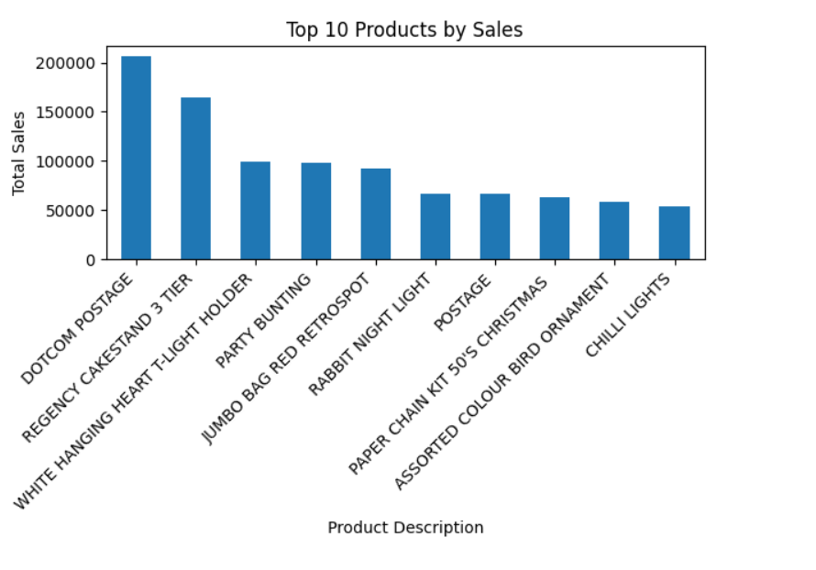

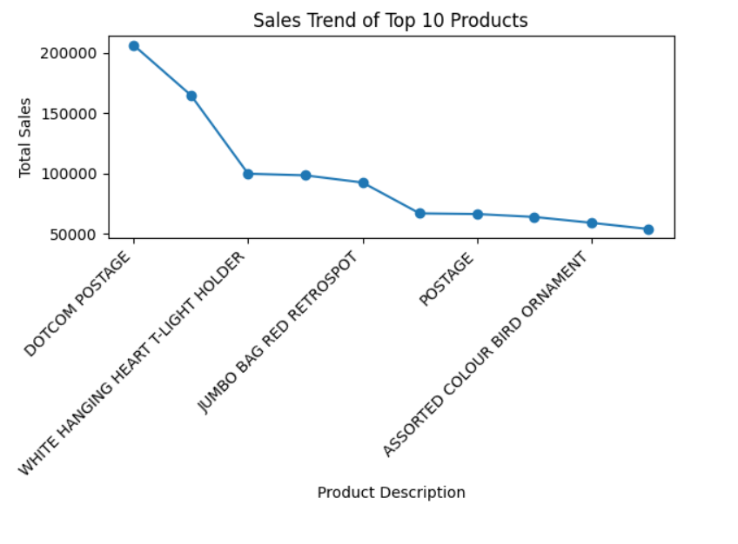

Scenario – 2:
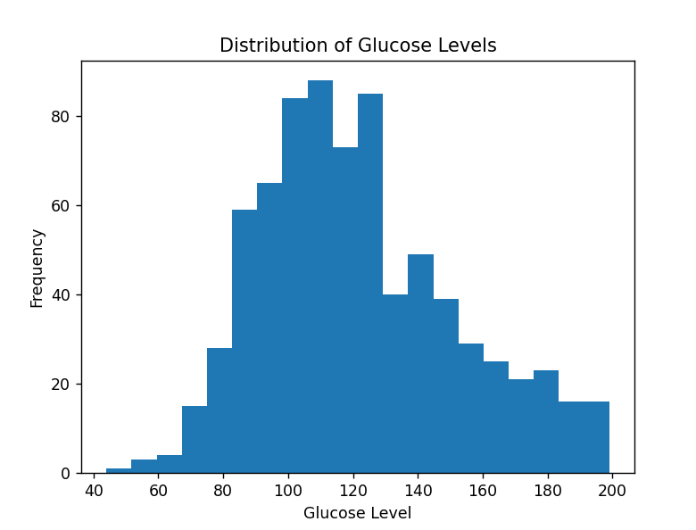
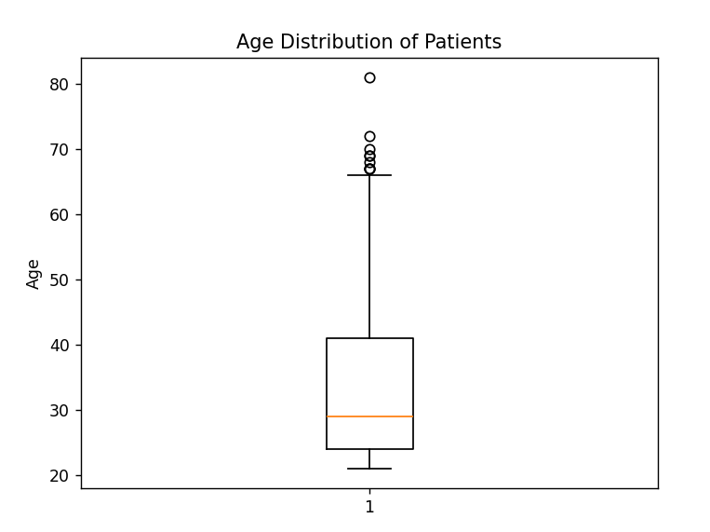
Scenario – 3: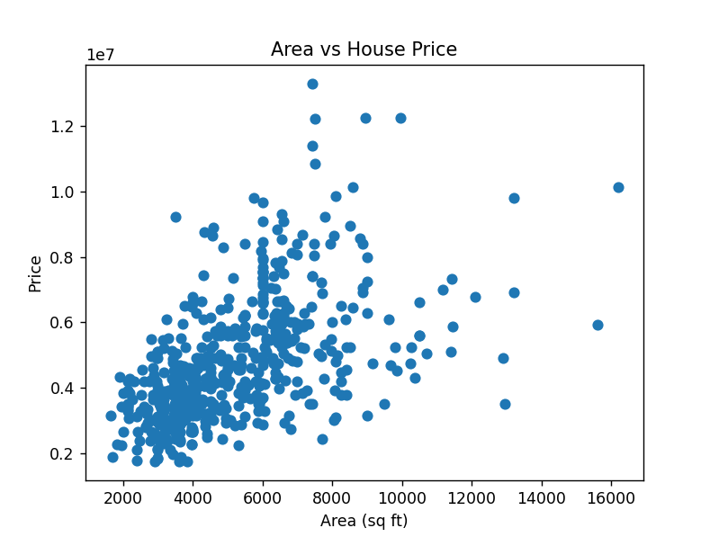
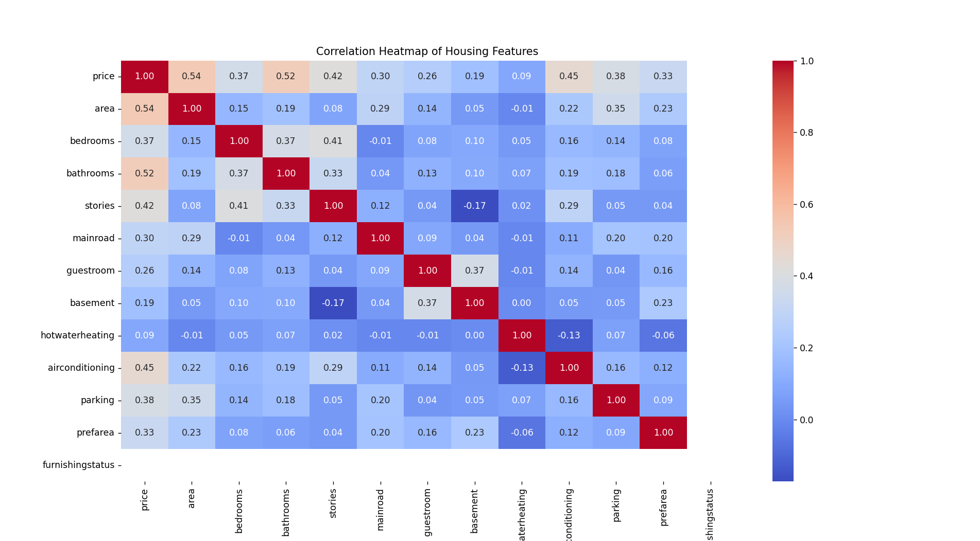

Scenario – 4:
